

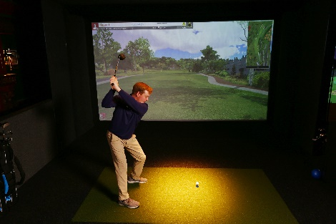 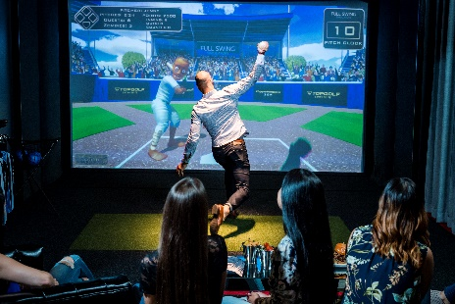

**Virtual Golf Baseball**

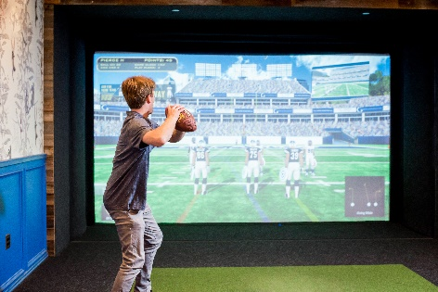 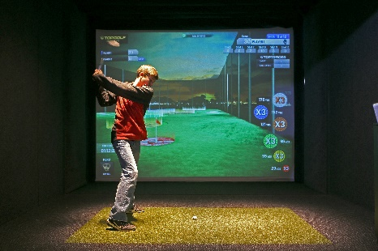

**Football Top Golf**

The Topgolf Swing Suite, located in the Atrium on the lobby level, offers a variety of virtual games – including signature Topgolf target games, Pirate Wars, Hockey, Baseball, Football and[**more**](http://bit.ly/SwingSuiteGames) – paired with comfortable lounge seating, HDTVs, and food and beverage service.

See the Front Desk or Bartender for Golf Clubs and to reserve the Swing Suite today.

Hours of Operation 9:00 am – 10:00 pm.

Scan the QR code below to reserve the swing suite.

