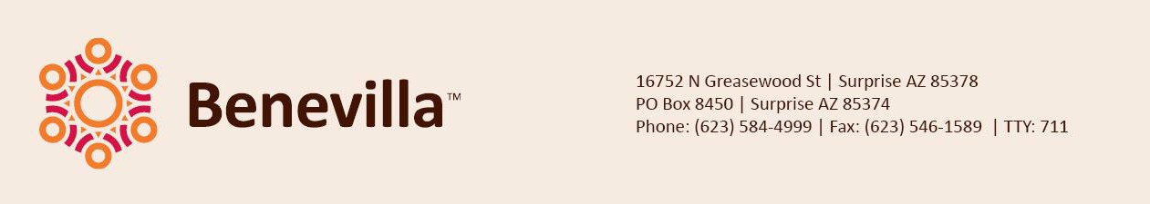

|  |  |
| --- | --- |
| May 7, 2025  **FOR IMMEDIATE RELEASE** | Contact: Ben Andree  Director of Marketing  623-584-4999  bandree@benevilla.org |

**Free Benevilla Workshop Offers Practical Help for Caregivers: “When Bathing and Grooming Become the Battle”**

**Surprise, AZ** - Benevilla is proud to present a compassionate and informative workshop designed specifically for family caregivers: “When Bathing and Grooming Become the Battle,” happening Thursday, May 22 from 1:00 to 2:00 PM at the Benevilla Education Center (14601 N Del Webb Blvd, Sun City, AZ 85351).

Leading the workshop is Debbie Gross of Home Instead Surprise, who brings deep expertise and empathy to one of caregiving’s most common and challenging experiences—helping a loved one with personal hygiene when they resist.

“Personal care challenges can often lead to stress and strain between loved ones,” says Jennifer Kehren, Director of C.A.R.E.S. and Volunteer Services at Benevilla. “This workshop provides caregivers with tools to reduce conflict and create a more peaceful, respectful care environment.”

Attendees will learn practical tips and gentle approaches to personal care that preserve dignity and reduce resistance. The workshop will also include a Q&A session, giving caregivers the opportunity to ask questions and receive personalized advice.

The event is free and open to the public, but space is limited. Registration is required.  
To register, visit: <https://benevilla.org/education-workshops-2025/>

**About Benevilla**: Started by the community and for the community in 1981, Benevilla is a not-for-profit family services agency dedicated to enriching the lives of West Valley residents by providing care

services for older adults, adults with disabilities, children, and families. For more information on

services, volunteer opportunities, to take a tour or donate to Benevilla, call 623-584-4999 or

visit [www.benevilla.org](http://www.benevilla.org).

**Photos:**

Community members attend a Benevilla workshop, engaging in an informative session focused on senior services and support resources.

**###**