

|  |  |
| --- | --- |
| April 9, 2025  **FOR IMMEDIATE RELEASE** | Contact: Ben Andree  Director of Marketing  623-584-4999  bandree@benevilla.org |

**Benevilla to Host 2025 Wellness Resource Fair Empowering Older Adults for Healthy Aging**

**Surprise, AZ -** Benevilla is proud to partner with top community providers to present the 2025 Wellness Resource Fair, a free and informative event designed to connect older adults and their families with valuable tools for healthy aging. The fair will take place on Thursday, April 17, 2025, from 9:00 AM to 12:00 PM at the Ottawa University Student Union, located at 14360 W Tierra Buena Ln, Surprise, AZ 85374.

Attendees will have the opportunity to engage with Benevilla’s Preferred Partners, including a wide variety of senior-focused organizations such as Hospice of the Valley, Adultcare Assistance, Sun Health Communities, and many more. This is a unique chance to explore local resources, consult with industry experts, and discover practical solutions for aging well.

Highlights of the event include:

* Free Vaccine Clinic provided by Albertsons Osco Pharmacy – Flu, COVID-19, pneumonia, shingles, RSV, Tdap, and Hepatitis B vaccines available at no cost with private insurance, Medicare, or Medicaid card.
* Medication Review Station – Know your meds! Free consultations and pill box assistance available.
* Special Guests:
  + Chef for Seniors – Learn about healthy, at-home cooking tailored for older adults.
  + Memory Lane Games – Discover an engaging app created for individuals living with memory loss.
  + VA Advocate/Pension Care Planner – Get informed about veterans’ benefits that may be available to you.

Plus, enjoy refreshments, door prizes, raffles, and more.

“This fair is a wonderful way for older adults to connect, learn, and thrive,” said Benjamin Andree, Director of Marketing at Benevilla. “We’re excited to bring our community together with trusted partners to provide practical resources that support independence and quality of life.”

The event is free and open to the public. For more information, visit [www.Benevilla.org](http://www.Benevilla.org) or follow us on social media.

**About Benevilla**: Started by the community and for the community in 1981, Benevilla is a not-for-profit family services agency dedicated to enriching the lives of West Valley residents by providing care

services for older adults, adults with disabilities, children, and families. For more information on

services, volunteer opportunities, to take a tour or donate to Benevilla, call 623-584-4999 or

visit [www.benevilla.org](http://www.benevilla.org).

**Photos:**

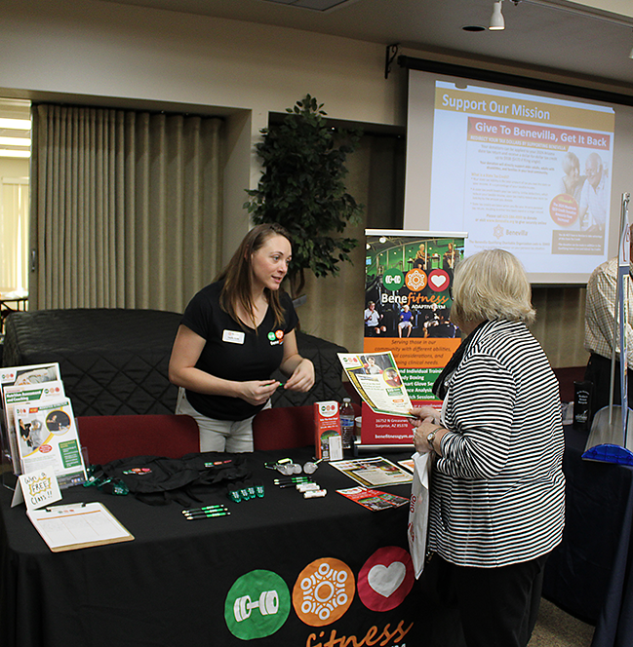

A Bene*fitness* team member shares wellness resources with a community guest at a previous health and resource fair. This year’s event will offer free vaccines, expert consultations, and more to support healthy aging.

**###**