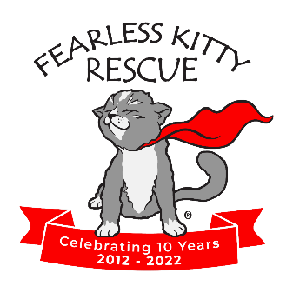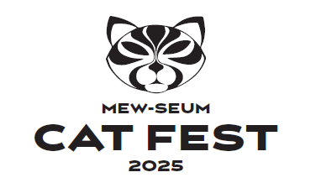

Media Contacts:
Deanna Schlagenhaft, Executive Director, Fearless Kitty Rescue, info@fearlesskittyrescue.org
480-837-7777
Mel Stevens, MWS Consulting, mewstevensaz@gmail.com, 602-402-9097

***FOR IMMEDIATE RELEASE***

FEARLESS KITTY RESCUE PARTICIPATES IN MEW-SEUM CAT FEST 2025
See Some Adoptable Kitties March 15, 10 AM – 4PM
Fountain Hills, Arizona, March 7, 2024 – Fearless Kitty Rescue is participating in Cat Fest 2025 at the Mesa Historical Museum on March 15 from 10 AM – 4 PM. This free event includes museum admission.
Fearless Kitty Rescue was selected as one of three featured rescues at this event with guest speakers talking about TNR, Neonatal Kitten Care and AZ Cat History. There will be over 40 vendors with cat crafts, food and cat art work.
The rescue will have some adoptable kitties including one or two brought from fire-ravaged Los Angeles if they are still available.
Here are the details:
When: Saturday, March 15th, 10:00 am – 4:00 pm
Where: 2345 N. Horne Road, Mesa at the Mesa Historical Museum
- Get crafty with cat-themed arts & crafts, including DIY cat toy making!
- Shop local vendors offering purr-chases for cats and their people.
- Learn from feline-focused educational talks.
- Meet adorable adoptable kitties from local rescues.
- Enjoy delicious food from local food trucks.
- Plus, other exciting surprises!

For additional information go to https://www.visitmesa.com/events/mesa-historical-mew-seum-cat-fest-2025/ or visit https://fearlesskittyrescue.org/events-calendar-2/

About Fearless Kitty Rescue

Founded in 2012, Fearless Kitty Rescue is a recognized 501(c)(3) non-profit, no-kill cat rescue. Fearless Kitty Rescue is dedicated to providing a safe place for cats in need until they can be adopted into a loving home. At Fearless Kitty Rescue we believe in a future when all cats live happy and healthy lives, free from loneliness, cruelty and neglect.
Fearless Kitty Rescue also serves as an information resource to the community and all pet owners by providing education and information on responsible pet ownership, including the importance of spaying/neutering, positive behavior training, and good nutrition.
To learn more visit www.fearlesskittyrescue.org and follow: @fearlesskittyrescue on Facebook, Instagram & TikTok; @FearlessKitty12 on Twitter; and Fearless Kitty Rescue on YouTube.

###

