**FOR IMMEDIATE RELEASE**

**January 7, 2025**

**Contact:**

Lara Ludwig

With a Twist Consulting

Phone: 480-878-0058

Email: withatwist.lara@gmail.com

**LOCAL ARIZONA NON-PROFIT throwing An exciting event and auction to**

**help save arizona**

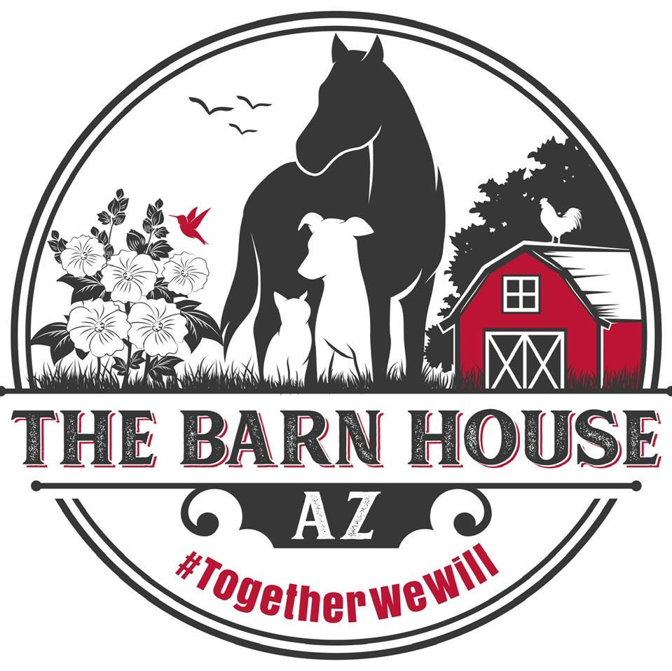

**PHOENIX, AZ** – (7624 West Banff Lane, Peoria, AZ) On Saturday, March 15, 2025 from 5pm-9pm, The Barn House AZ will hold their signature fundraiser Lucky Clover Barn House Benefit.

**The Barn House AZ:** The Barn House AZ, where animals bring out the best in humanity. Mission: Build a community of purpose for animals and the people that love them.

Join us on March 15,2025 for an exciting evening of live music. There will be local food trucks, silent auction, games and much more! Stay tuned for details to come! [www.barnhouseaz.com](http://www.barnhouseaz.com)

Tickets are on sale now at : [Lucky Clover Barn House Benefit Tickets, Sat, Mar 15, 2025 at 5:00 PM | Eventbrite](https://www.eventbrite.com/e/lucky-clover-barn-house-benefit-tickets-1104698445789)

Tickets include a meal, dessert and 2 drinks.

###