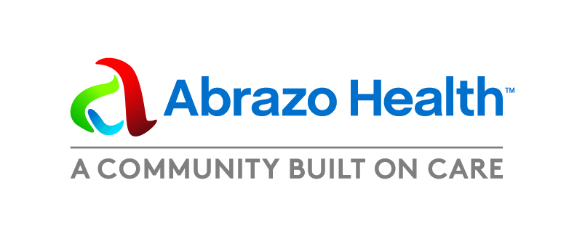**News Release**

**Dec. 20, 2024**

Media contact:

Linda Nofer

Communications Manager

Abrazo Health

480-510-2353

**Be Your Own Heart Hero**

*Abrazo Health Announces 2025 Heart Month Campaign*

**PHOENIX** — Abrazo Health is excited to share details about its 2025 Heart Month Campaign, “Be Your Own Heart Hero.” The 2025 campaign aims to encourage you to take charge of your heart health while emphasizing the support available from Abrazo Health. The campaign runs Dec. 2024 through Feb. 28, 2025.



Abrazo Health hospitals are offering the opportunity to win one of 25 pair of wireless earbuds and download a free 28-day heart-healthy activity calendar to receive health tips and celebrate Heart Month 2025. Join our heart care team in its mission to provide you with helpful information, activities and videos geared towards maintaining and improving your heart health - the best armor in the fight against heart disease.

Earbud winners will be randomly selected from eligible entries March 1, 2025. As a bonus, entrants will receive weekly emails during February with heart-healthy tips.

“February is the perfect time to embrace a healthier you because Heart Month can inspire every generation to work on maintaining or improving heart health,” says Dr. David Prutzman, Interventional Structural Cardiologist, Abrazo Health.

Taking control of your heart health is more important than ever – no matter if you’re young or old, because heart disease affects every generation; in fact, as many as 4% to 10% of all heart attacks occur before the age of 45. And about one in 20 adults aged 20 and older have coronary artery disease.

An unhealthy diet in childhood is associated with adverse cardiovascular health in adulthood. Many cardiac disorders and risk factors for heart disease (high blood pressure and high cholesterol) are inherited. However, lifestyle, diet and exercise can reduce these risk factors. *Sources: CDC, NIH, Harvard, National Academy for Medicine.*

“Your heart care team includes more than your medical team. Our goal for 2025 Heart Month is to encourage the community to embark on the heart health journey together with friends and family members. This can help keep you accountable to your health goals and make the journey more enjoyable,” says Dr. Prutzman.

[Click here](https://www.abrazohealth.com/campaigns/heart-month/sign-up?c=ALYPT&utm_source=qr_code&utm_medium=PRT&utm_slc=CARD+LYH&utm_loc=ACHN&utm_lan=en&utm_cta=SUB) to enter the “Be Your Own Heart Hero” giveaway sweepstakes. This campaign is about empowering you to take control of your heart health and allow Abrazo Health hospitals to be trusted partners in your journey.

###