Our December presenter is Vicki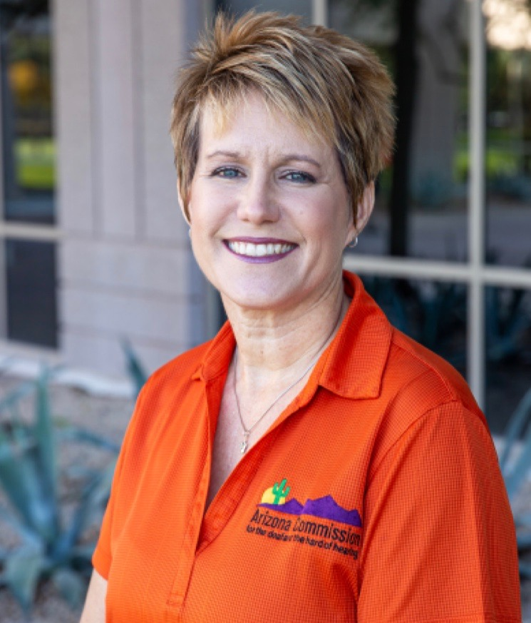 Thompson, Program Planner for the Arizona Commission for the Deaf and the Hard of Hearing. Her presentation, entitled AzTEDP, 2024 and beyond: More Choices Equal More Independence, will provide you with specific information about items like amplified phones, alerting equipment for incoming calls, bed shakers, and vibrating alarms. All to make your life easier.

Vicki has been with the ACDHH in a full-time roll since 2004. The majority of her roles are with the public. She enjoys helping clients, families, friends and other professionals with the process of solving communication and other problems. In addition to awards won, her biggest highlights are the genuine thank you’s from those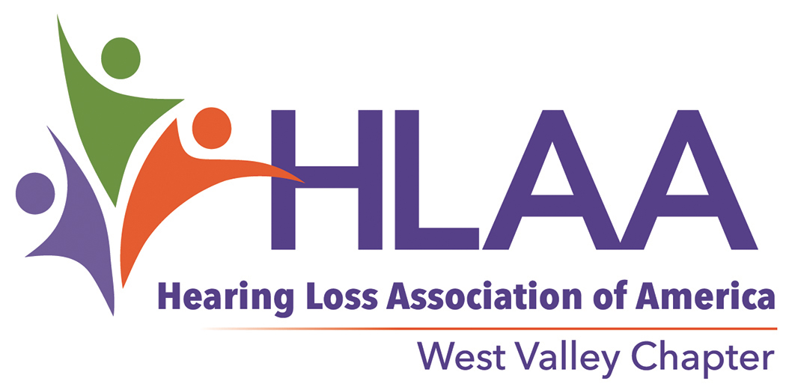AZWESTVALLEYCHAPTER.tiff she has positively impacted over the years. Vicki’s goal is to make people feel valued, seen, heard and respected. Her favorite quote is “We rise by lifting others.”

Join Us

Tuesday, December 10, 2024

12:00 pm

**Meeting Location**:

First Presbyterian Church

12225 N. 103rd Avenue

Sun City, AZ 85351

**Meeting Dates:**

Second Tuesday of the month from October - May

**Meeting Time:**

12:00 p.m. - 12:45 Brown Bag

1:00 p.m. - 2:30 p.m. Meeting

**Questions?**

Melanie O’Rourke, President

[melanie.orourke@gmail.com](mailto:melanieorourke@gmail.com)

623-882-5554

Fred Williams, Vice President

[willzoom@cox.net](mailto:willzoom@cox.net)

The [West Valley Chapter](http://www.hlaawestvalleyaz.org) is a local chapter providing education, information, support and advocacy for people with hearing loss. Visit our website:

[www.hlaawestvalleyaz.org](http://www.hlaawestvalleyaz.org) and like us on Facebook:

[HLAAWestValleyAZ](https://www.facebook.com/HLAAWestValleyAZ)

The Hearing Loss Association of America is the nation’s foremost membership and advocacy organization. Visit the website: [www.hearingloss.org](http://www.hearingloss.org)

Pack a lunch (brown bag) and we’ll eat together and share a fun time from 12:00 - 12:45 p.m. learning about different technologies available on your iPhone or Android. Our regular meeting and Vicki’s presentation starts at 1:00 p.m. The meeting ends at 2:30 p.m.

There is no charge for the meetings.

Meetings are amplified and the room has an induction loop system. Captions are provided for the speakers’s presentation.

Consider inviting a family member or friend, with or without hearing loss, and prepare for an informative and entertaining discussion.