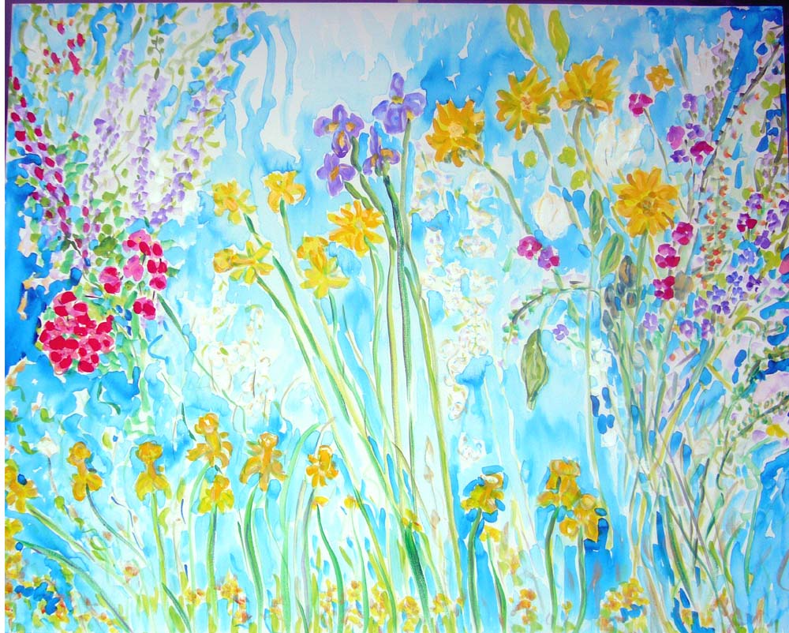
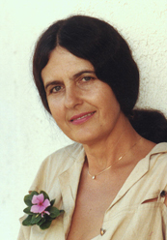
Andrea de Kerpely-Zak

Gallery Andrea
7019 E. Main St.
Scottsale, AZ 852151

Andrea de Kerpely-Zak Tel: 480 481 2530
Artist

Joyful

Hungarian born Artist, studied painting with Janos Nagy(Hungary)
and Arthur Lismer (Group of Seven) Canada.
Award winner, exhibitions in solo and group shows, Hungary, Canada & U.S.A.
While revisiting her native Hungary, collected
“Wildflowers,” which inspired her watercolor paintings.
Her series of Arizona Wildflowers were published with Georgia O’Keefe in Arizona Highways
She paints all media, received invitations to exhibit: Sweden & Hungary
Her work has been exhibited and sold around the world over 35 years.
Andrea’s work is called, “Healing,” by Magazines and Collectors and exhibited at Mayo Clinic for a Healing Floral Show.
Her work is in private and corporate collections worldwide
including Vatican City (Rome) painted for Pope John Paul II
Appointed:
Judge, Arizona State Fair Fine Arts (1980, 1983,1984)
Publications:
Arizona Highways (3/82) , Southwest Art (Best of the West)
The Wedding Chronicle (7/01) “Flowers that Last a Lifetime.”
Scottsdale Magazine (7/ 04), Art Book New West (4/05),
Phoenix Magazine 6/05(Artist of Month), Best of Scottsdale 2005 Finalist
Phoenix Home Garden 10/06 Editorial & 04/08, Artbook New West
Television Interviews:
KPNX 12, ABC 15, KTVK 3, “Universal Art” T.V. Show
Her gentle touch evokes the “Delight of Flowers,” portraying a “Mood or Moment in Time.”
Collectors say her paintings have “Healing Powers” such as Ann Sakowitz.

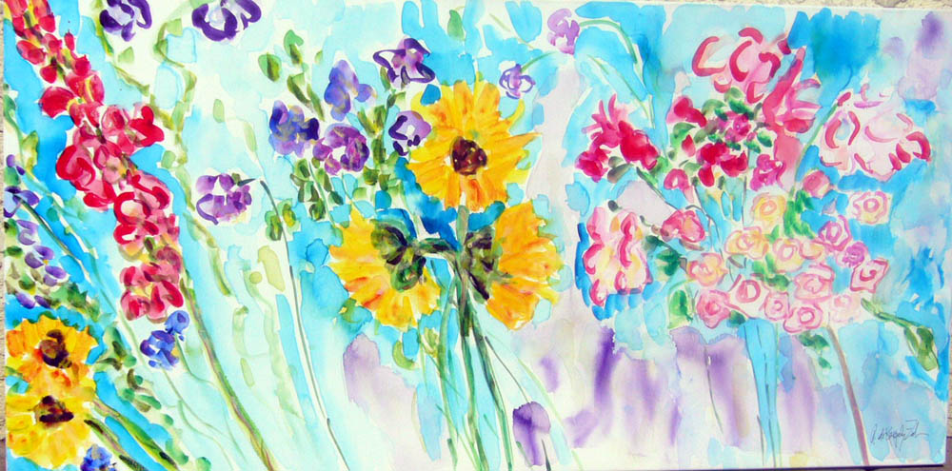
Artist Statement:

“With the changing light I create a mood or moment in time. I achieve this through my spontaneous brush strokes.”

“Joy”

