**Working in the Pentagon:**

**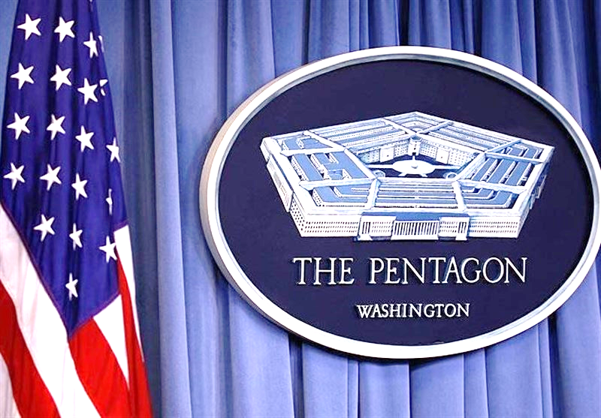The Seat of Our Nation’s Military Power**

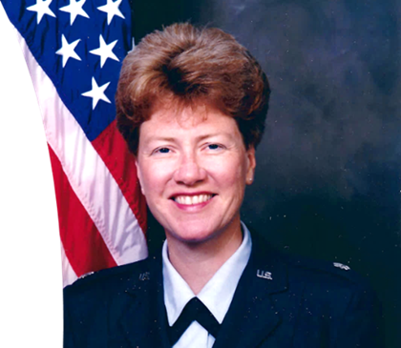Join Fountain Hills resident Darla Roberts as she discusses the 6.5 years she worked in the Pentagon, the center of the world’s most powerful military. Darla spent a three-year assignment of her US Air Force military career in the Pentagon. She later spent another 3.5 years in the Pentagon as a civilian Department of Defense contractor. Darla worked there before the 9/11 attacks as a military member, then again after the 9/11 attacks. She worked in the section of the Pentagon that was destroyed on 9/11 and then rebuilt in record time. Join Darla for a look at the history of the building itself, how it changed after 9/11, and a first-hand look at what the day-to-day work life is really like in the seat of our Nation’s military power.

**Length**: 60 minutes w/ Q&A

**Date/Time: Dec 5th, 2024, 1PM**

**Registration:** Begins 11/21/24

**Location:** Fountain Hills Library, Non-Fiction Lounge

**Lt Colonel Darla Roberts - Pentagon**