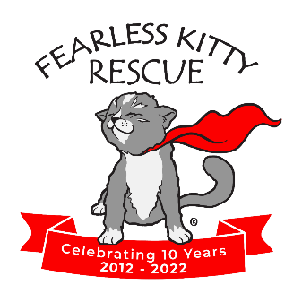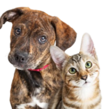

Media Contacts:
Linda B, Fearless Kitty Rescue, info@fearlesskittyrescue.org, 480-837-7777
Mel Stevens, MWS Consulting, mewstevensaz@gmail.com, 602-402-9097

***FOR IMMEDIATE RELEASE***

FEARLESS KITTY RESCUE FREE MICROCHIP EVENT AND OTHER FALL EVENTS
Final Microchip Event of the Year November 16th, 10AM – 12NOON
Fountain Hills, Arizona, October 21, 2024 – Fearless Kitty Rescue is hosting its final FREE microchip event of the year for cats and dogs on Saturday, November 16th.
Did you know: The American Veterinary Medical Association has reported that one in three pets will go missing at some point. Of those, only 22% of dogs and less than 2% of cats are returned to their families. The percentage rises dramatically, however, if the dog or cat is microchipped.
A microchip is the best way to ensure pets are quickly identified and reunited with their families.
Here are the details:
When: Saturday, November 16th, 10:00 am – 12Noon
Where: 16832 E. Avenue of the Fountains, Fountain Hills, AZ. 85268 – North Parking Lot

Here is what you need to know:

Event is free thanks for generous donation of microchips by fi-NANO

No appointment required

Cats must be in carriers

Dogs must be on leashes

Other Fall Events

PetCo Fountain Hills Adoption Event October 26th from 10:00AM – 12Noon at 16835 E. Shea Blvd.

Fearless Kitty Rescue will also be participating in the Fountain Hills First Friday Event on November 1st when the rescue will be open 4:00PM to 6:00PM for visitors and tours.

And, as is tradition Fearless Kitty will be open and have an outside table at the Fountain Hills Festival from November 8th through November 10th.

About Fearless Kitty Rescue

Founded in 2012, Fearless Kitty Rescue is a recognized 501(c)(3) non-profit, no-kill cat rescue. Fearless Kitty Rescue is dedicated to providing a safe place for cats in need until they can be adopted into a loving home. At Fearless Kitty Rescue we believe in a future when all cats live happy and healthy lives, free from loneliness, cruelty and neglect.
Fearless Kitty Rescue also serves as an information resource to the community and all pet owners by providing education and information on responsible pet ownership, including the importance of spaying/neutering, positive behavior training, and good nutrition.
To learn more visit www.fearlesskittyrescue.org and follow: @fearlesskittyrescue on Facebook, Instagram & TikTok; @FearlessKitty12 on Twitter; and Fearless Kitty Rescue on YouTube.

###

