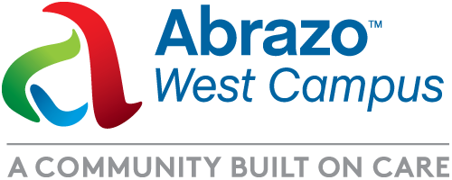**MEDIA ADVISORY**

**Oct. 22, 2024**

Media contact:

Linda Nofer

Communications Manager

Abrazo Health

480-510-2353

Delivering the Future of The West Valley

*Celebrate our Newly Refreshed Labor and Delivery Department at Abrazo West Campus*

**Who:** Media and public invited and welcome!

**What:** Grand tour of newly refreshed labor and delivery department, entirely centered around the needs of mothers and babies. Just some of the new, unique offerings you will see:

*CuddleCot* – A new device to support bereaved families by giving them additional time to say goodbye to their stillborn child while they begin the grieving process. Designed to give families time to create precious memories of their child and allow parents to make final arrangements for their baby without feeling rushed.

*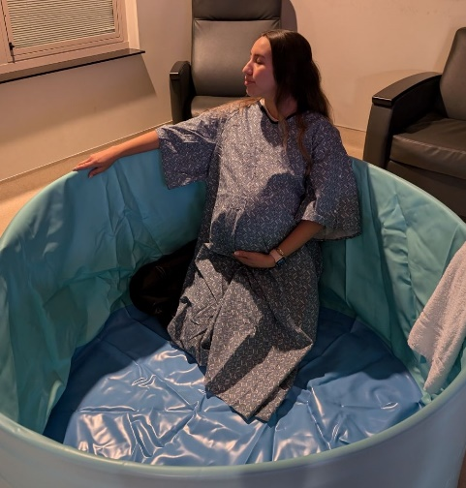AquaDoula* – Premiere, heated, portable birth spa/pool developed specially for comfort and care during labor. A warm, soothing pool, the AquaDoula is the top choice of midwives and expectant parents.

*Wireless Fetal Monitoring* – Advanced technology that wirelessly monitors pregnant moms during labor, providing them freedom to move around safely while laboring. It measures/displays maternal and fetal heart rates, contractions, and uterine activity and transmits the data to hospital clinicians.

“This wireless monitoring system is a game-changer for improving the labor and birthing experience by giving women in labor greater freedom of movement because they are not continuously connected by cords to a fetal monitor,” says Jordan Oland, MD FACOG, Physician/Partner, Estrella Women's Health Center/Women’s Health Arizona

**Where:** Abrazo West Campus,13677 W. McDowell Rd, Goodyear, AZ 85395, Labor & Delivery Lobby

**When:** October 22, 2024, 3 – 6 p.m.

**Why:** Having a baby is a special, life-changing event. That’s why at Abrazo Health we design healthcare centered around personalized and compassionate care to make the birth experience as healthy and joyful as possible.

The West Valley is the third fastest growing community in the United States, and Abrazo West Campus is growing too, keeping up with the expanding population with exceptional doctors and the finest equipment for patients. We are proud to offer the best in care to women, before, during and after childbirth.

###