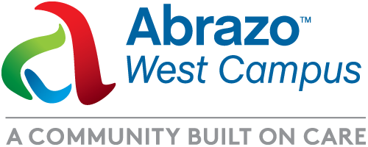**MEDIA ADVISORY**

**Oct. 26, 2024**

Media contact:

Linda Nofer

Communications Manager

Abrazo Health

480-510-2353

**Helicopters, Firetrucks and Ambulances, Oh My!**

*Join us for the Abrazo West Campus’ Annual RESCUE ROUNDUP*

**WHO:** Abrazo West Campus is excited to host its annual Rescue Roundup! A free, community health and safety fair with lots of interactive fun for you and your family.

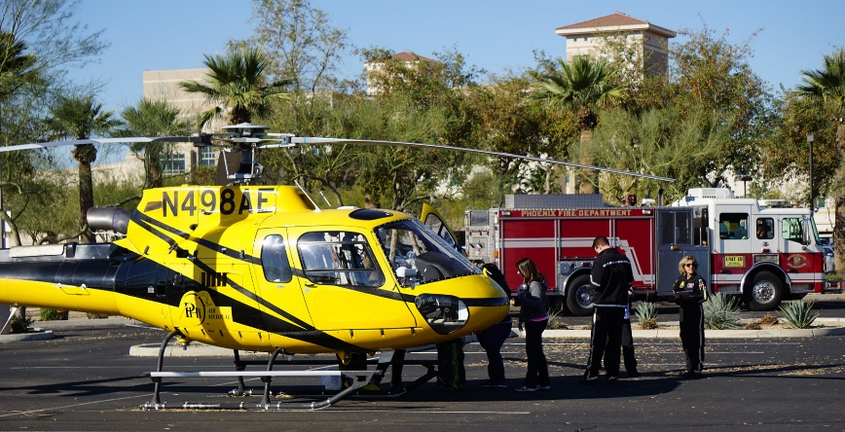**WHAT:** A spectacular family fun-filled event featuring:

* CPR demonstrations
* Car seat safety checks
* Vehicle extrication demonstrations
* Fire trucks
* Ambulances
* Rescue helicopters
* A police SWAT vehicle and meet a K-9 officer
* Police and first responders
* Bike helmet distribution and a bicycle safety course
* Free food and drinks and more!

**WHEN:** Sat. Oct. 26, 9 a.m.-12 p.m.

**WHERE:** Abrazo West Campus, 13677 W. McDowell Road, Goodyear, AZ (East Parking Lot)

**WHY:** Abrazo collaborates with emergency responders and public safety agencies from throughout the West Valley for this health and safety fair sofamilies can enjoy interactive fun. The West Valley is the third fastest growing community in the United States and Abrazo Health is dedicated to bringing together residents in the communities we serve to promote good health, public safety and education.

###