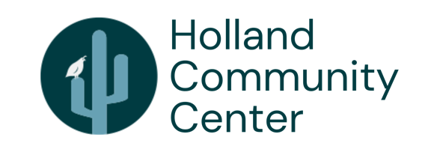

**FOR IMMEDIATE RELEASE**

**Desert Foothills Book Festival Returns to Holland Community Center**

***With a mission of promoting an appreciation of the literary arts, this free event invites attendees to connect with over 85 local authors from various genres.***

**SCOTTSDALE, Ariz. –** The Holland Community Center, in partnership with Desert Foothills Library, is excited to present the 3rd Annual Desert Foothills Book Festival on Saturday, October 19, 2024 from 10 a.m. to 3 p.m. Attendees of this free event will have a chance to meet over 85 local authors (of whom nearly 50 are new to the festival), win prizes and gift baskets, and purchase signed books, with over 300 titles to choose from across a wide array of genres. The festival will take place at the Holland Community Center, 34250 N. 60th Street, Scottsdale, Ariz. 85266.

Inspired by a group of local authors seeking to personally connect with book lovers and promote an appreciation of the literary arts, the Desert Foothills Book Festival celebrates the importance of reading in the greater Phoenix, Scottsdale, Carefree and Cave Creek communities. Designed for children and adults alike, the festival provides an interactive, inclusive venue for readers and authors to connect. Net proceeds from the festival support local literacy programs.

“Arizona authors are a vibrant, varied and caring bunch, eager to share their craft and enrich the lives of those in our community,” said Caren Cantrell, children’s author and chairperson of the Desert Foothills Book Festival. “The festival is a truly unique event for the Valley. We’ve doubled in size since our inaugural 2022 festival and expect this year to be even bigger and more diverse. And it all goes to a great cause.”

Last year, the beneficiary of proceeds from the festival was a program called Creative Kids – Tell Me A Story. Presented by the Holland Community Center, this unique and inspiring program taught fifteen kids, ages 8 to 10, the nuances of writing, illustrating and speaking to spark their creativity and further the art of storytelling. At the end of the six-week program, each child had a published book to show off to their friends and family at a mini-book fair. Plans for this year include expanding Creative Kids to include a poetry slam for high schoolers and a “Page to Stage” program, in which kids will write a stage play and then act it live on stage.

To learn more about the Desert Foothills Book Festival and view a list of participating authors, visit <https://desertfoothillsbookfestival.com>.

###