FREE CONCERT

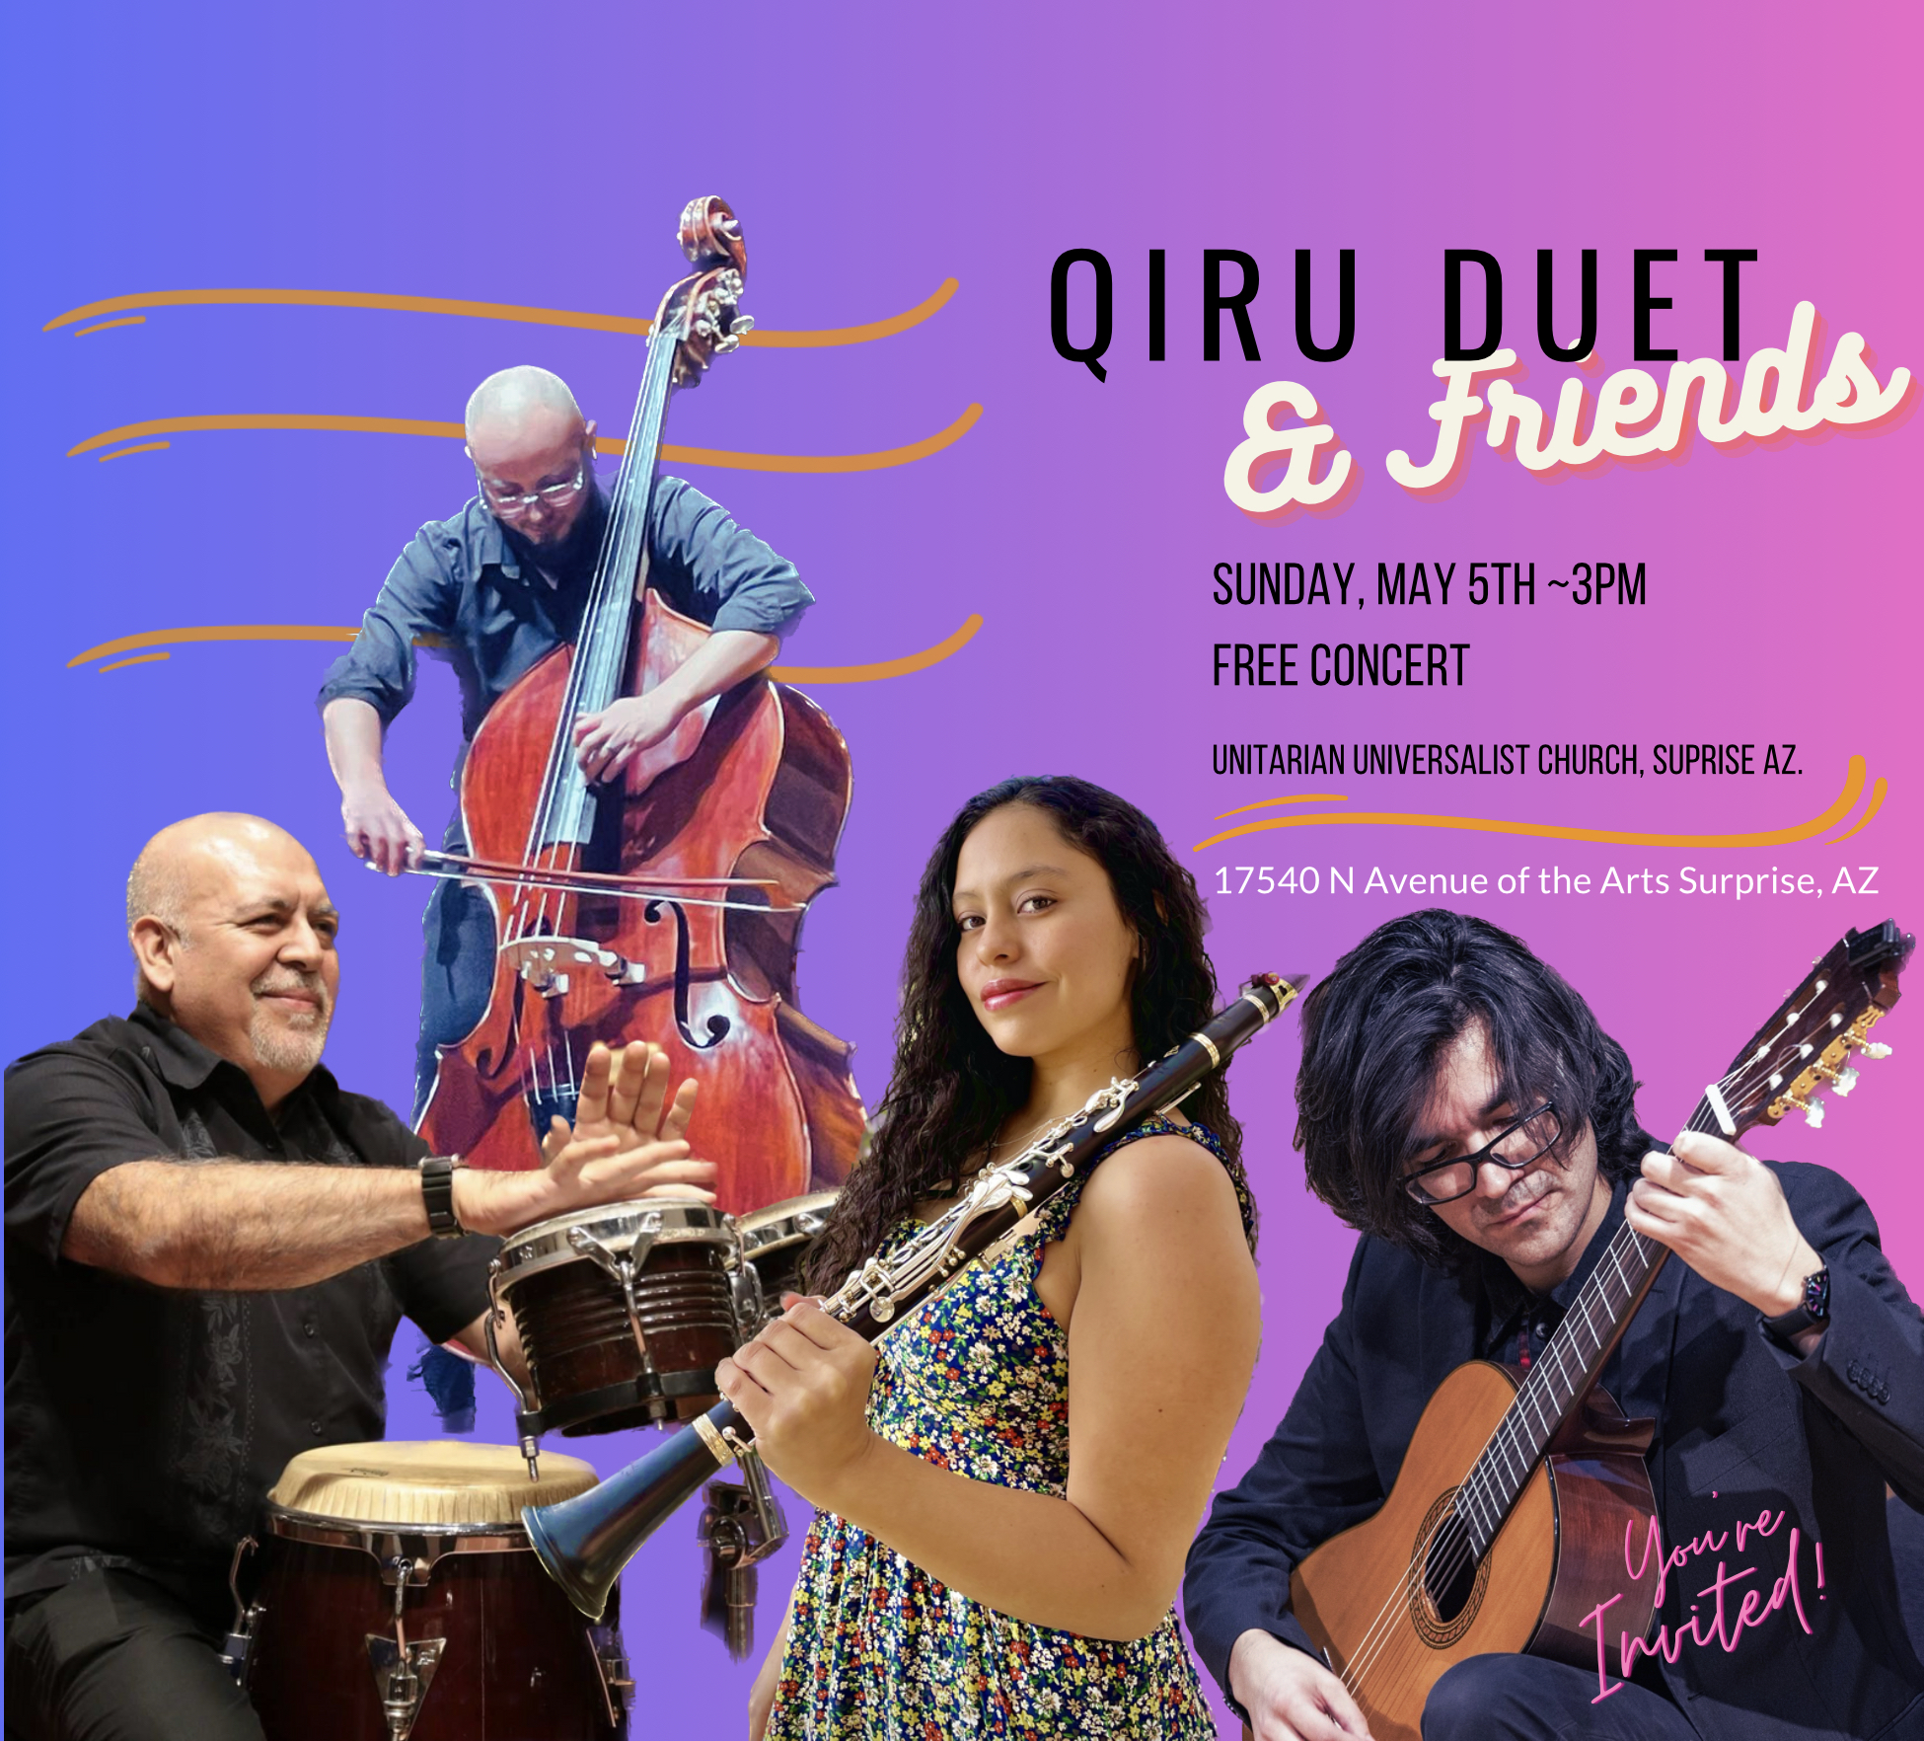

This popular international group returns on Sunday, May 5th, at 3pm.

The name "Q’iru" comes from the Quechua language, indigenous to the people of South America, meaning "wood," which symbolizes the instruments in their ensemble: Clarinet, Guitar, Double-Bass, & Latin Percussion.

Their performances feature selected pieces representing diverse genres, including the passionate Tangos of Argentina, the lively Choros of Brazil, the soulful Tonadas of Chile, the rhythmic Cumbias of Colombia, and many more captivating styles.

To get a taste of Q’iru’s performances, please explore their website at www.qiruduet.com, and visit the YouTube link where you will find a compilation featuring pieces such as "Seresta," "Danza Triste," and "Nostalgias," which will transport you to the heart of Latin America.

A free-will donation will be taken.

