Sounds of the Southwest Singers, Inc.
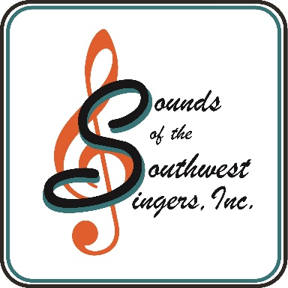
Matt Deller, Founding Director
director@soundsofthesouthwestsingers.com

E-mail: ssws@soundsofthesouthwestsingers.com
Website: www.soundsofthesouthwestsingers.com

PRESS RELEASE FOR SOUNDS OF THE SOUTHWEST SINGERS, INC. CONCERT SERIES FOR 4/21/2024 & 4/28/2024

The West Valley's own Sounds of the Southwest Singers and Sounds of the Southwest Chorale community choirs are uniting in song to perform their Sacred Sounds Concert, highlighting various arrangements of the many ever-popular well known and loved hymns, such as Come Christians Join to Sing, Great is Thy Faithfulness, and It is Well with my Soul. The Chorale will be presenting Joseph Martin's Cantata, Sanctuary: a Cantata of Hope and Peace, both groups are joining forces at American Lutheran Church on Sunday, April 21, at 3 PM, and again, on Sunday, April 28, at 3 PM, at Crown of Life Lutheran Church in Sun City West. Both events offer free admission; however, as a 501(c)(3) Non-Profit organization contributions are always appreciated, but never required.

Both choirs will perform individually and conclude jointly with additional inspirational singing, bringing together over 100+ voices for this unique musical experience.

The Sounds of the Southwest Singers perform year-round throughout the West Valley, and the Sounds of the Southwest Chorale performs annually, beginning in September through the following May. They have sung locally in various venues and for professional sporting events. Nationally they have performed on the famous stages of New York, and Washington DC, Disneyland, CA, Pearl Harbor, HI, Washington State and Alaska. Internationally they have performed in the UK, France, Germany, Austria, Ireland, and Italy. This fall, members of both choirs are scheduled to perform concerts throughout multiple cities in Italy.

In 2010, Founding Director Matt Deller formed the Sounds of the Southwest Singers (SSWS), and in 2015 he founded the Sounds of the Southwest Chorale (SSWC). In addition to his choral directing, Maestro Deller has performed professionally as a percussionist and timpanist in several orchestras spanning his nearly 35-year career. He mentors conductors and musicians to help them perfect their craft. Director Deller attends choral and orchestral workshops and seminars throughout the country, including in New York, at Oberlin Conservatory of Music, and Baylor University, to name a few.

Each group has an extensive repertoire, where the SSWS perform their ever popular Patriotic, Faith & Freedom concerts, Sounds of Broadway/Pop and their inspiring Sacred Sounds Concerts. They also perform a Sounds of Christmas and a Variety of Sounds Concert, where the music selections encompass all of the different genres in one concert. Later this year they are expanding their performances with a new category of songs, by presenting their new Sounds of the 60's and 70's. The SSWC is smaller in numbers and their repertoire ranges from the more traditional styles of music with a classical feel, to the cantatas of today's contemporary composers - Choplin, Fettke, Larson, and Martin, and others.

Join them on April 21, at 3:00 PM at American Lutheran Church, 17200 W Del Webb Blvd, Sun City, and April 28, at 3 PM at Crown of Life Lutheran Church in Sun City West, 13131 W Spanish Garden Drive. Each concert promises a deep emotional and spiritual connection. No two concerts are alike, there is something for everyone. They truly Unleash their Passion in Song!

