Press Contact: For Immediate Release

Lynn Kough

SDCpr@sonorandesertchorale.org

PRESENTS

MOVED BY THE SPIRIT: AMERICA’S HEART

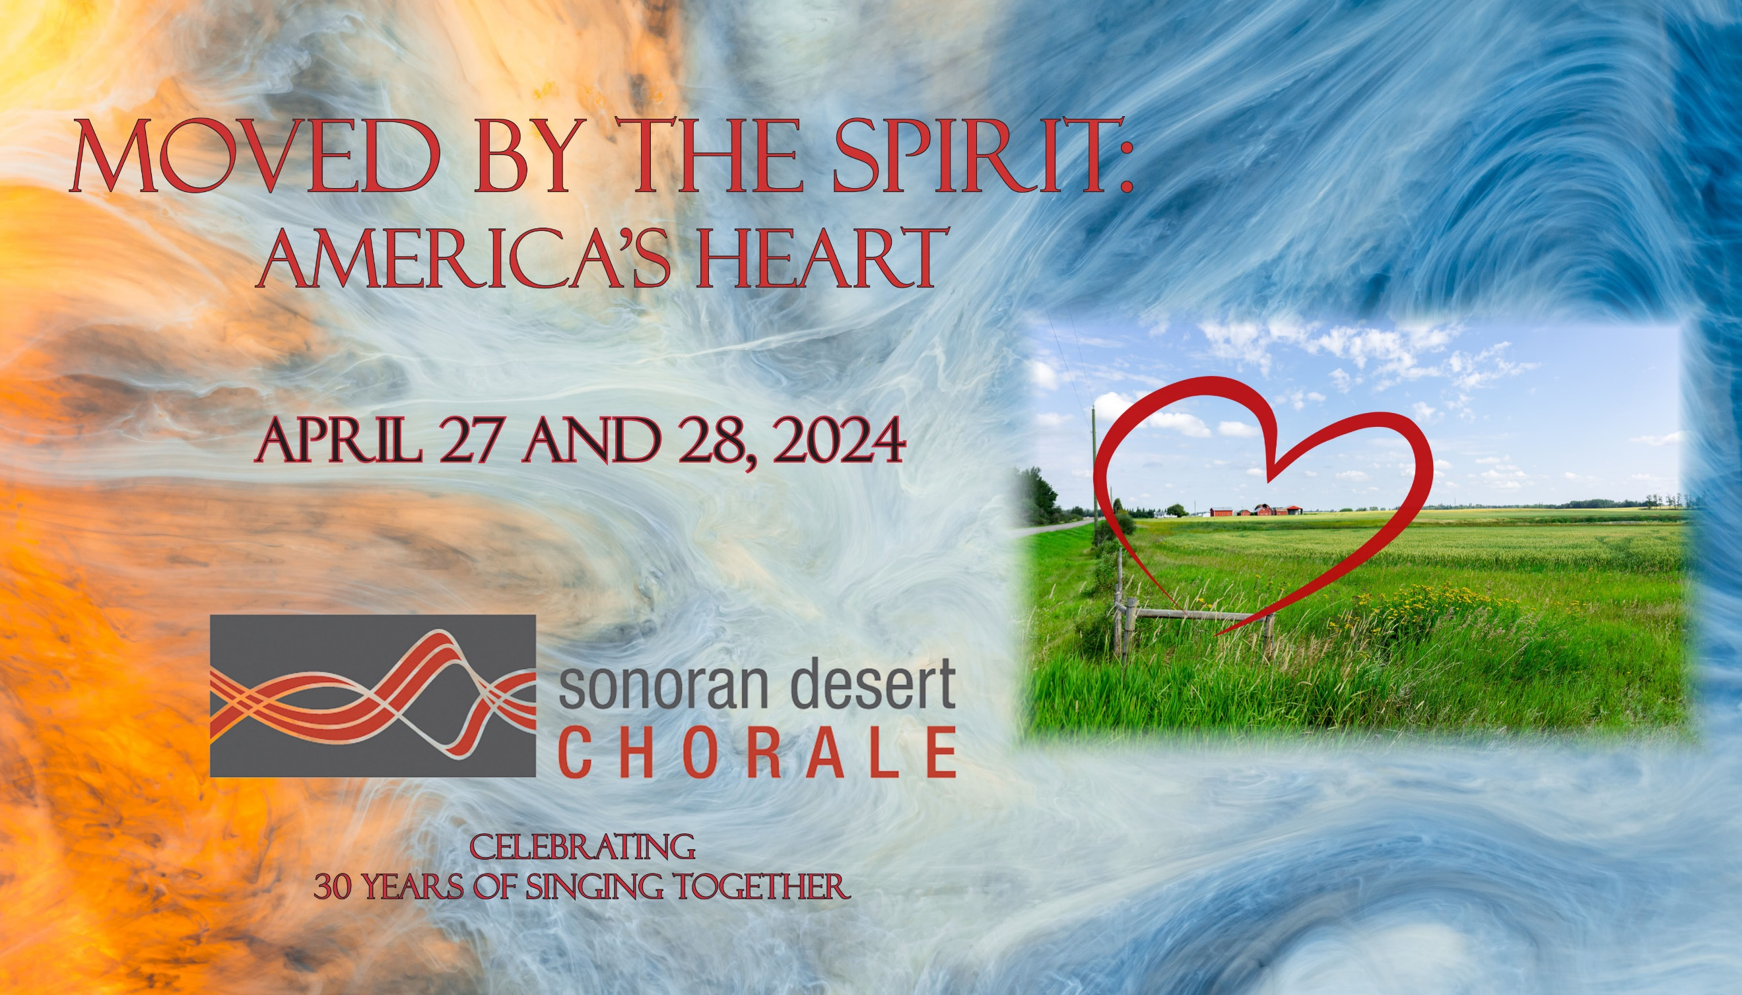

(Mesa, AZ) As the Chorale prepares for its long-awaited 7th European Tour, the concert repertoire reveals a distinctly American flair. Folk songs and spirituals plus a nod to our Spanish and French hosts create a celebration of cultures at home and abroad.

MOVED BY THE SPIRIT: AMERICA’S HEART performances are set for Saturday, April 27, 2024 at 7:30 P.M. at First United Methodist Church, 15 E. First Avenue, Mesa and Sunday, April 28, 2024 at 3:00 P.M. at La Casa De Cristo Lutheran Church, 6300 E. Bell Road, Scottsdale.

Single tickets are $25 for adults/$20 for seniors, students, and groups of 10 or more. Tickets may be purchased online at SonoranDesertChorale.org, by calling 480-305-4538, from singers, or at the door. Student Rush tickets are available ten minutes before curtain with appropriate ID.

A roster of American “Greats” including Z. Randall Stroope, Eric Whitacre, Alice Parker, Stephen Paulus, Jake Runestad, and Shawn Kirchner provide these perennial favorites – Come Let Us Sing a Song for Joy, Lux Arumque, The Road Home, Alleluia, and Unclouded Day.

Alice Parker was a powerful figure in American music. She served for 20 years as the chief arranger of pieces for the Robert Shaw Chorale, and this piece is from that period, with the original song dating to the mid-1850s. Her arrangement of Hark, I Hear the Harps Eternal is truly lovely and challenging, with complicated rhythms and a sort of canon. A joy to sing and to hear!

There are few melodies as recognizable as that of the American folk song Shenandoah. As with most folk songs, there are many different variations and versions, and it is impossible to determine the song's exact origin. It has commonly been sung as a sea shanty, though it most likely originated with early French Canadian fur traders. Versions of the song have linked it to riverboat men, cavalry men, mountain men, and soldiers on both sides of the Civil War. The Chorale offers the arrangement of this beautiful song where the lines are a call to the sailor wandering far out across the seas from the homeland itself, its rivers and its familiar and loved hills.

Come share in the depth of American song tradition, unite your hearts with ours as we bid adieu to our spirit-filled 30th Season, and wish us Bon Voyage to France, Spain, and the future!

About the Chorale
Sonoran Desert Chorale was founded in 1994 by Jeff Harris, who directed the group for twenty-five years. It is now led by Artistic Director, Dr. Craig Peterson. Since its inception, the group has become a highly regarded and sophisticated choral organization, presenting musical compositions from cultures around the globe as well as important pieces from the European and American music traditions. Concerts frequently include guest performances and collaborations with distinguished artists and organizations in the community. The Chorale has engaged in six international concert tours, with performances throughout Europe. The Chorale was invited to perform with Broadway superstar Michael Crawford for the inaugural concert of the $150 million Mesa Arts Center. The Chorale was selected to appear at the Western Division Convention of the American Choral Directors Association in Salt Lake City, UT.

For more information, high-resolution images, or to schedule an appearance or interview, please contact Lynn Kough at SDCpr@sonorandesertchorale.org.

# # #
Significant support is received from the Arizona Commission on the Arts. For more information, see and hear the Sonoran Desert Chorale on the web at SonoranDesertChorale.org

