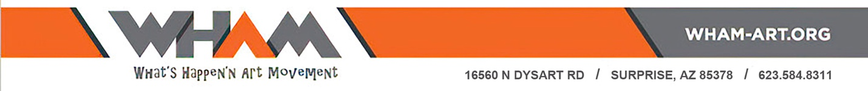

**Upcoming Event Press Release: WHAM Bowls of Hope Charity Event**

**For immediate release**

David Fudge, Marketing Manager

WHAM Art Association

928-380-5465

[David.Fudge@wham-art.org](mailto:David.Fudge@wham-art.org)

**Bowls of Hope for West Valley Charities**

WHAM-Art to hold its 9th annual ***Bowls of Hope*** sale and holiday celebration featuring local artists who help raise money and awareness to help eliminate hunger in the West Valley.

On December 2, WHAM Art Gallery, located at 16560 N. Dysart Road, Surprise, will make available for sale over five-hundred one-of-a-kind food safe glazed bowls in an open-air bazaar and art sale held in front of, and within, the gallery.  There will be an opportunity to glaze your own bowl in a classroom taught by local artist Marty Wolfe.

The proceeds from the sale will once again go directly to support local charities including St. Mary’s Food Bank and Eve’s place, Homeless Youth Connect, StreetLight USA, All Faith Community Services and the Valley Vista Community Food Bank.

‘This year we are adding to the event by providing entertainment and making available great food from a local business’, says Connie Whitlock, Executive Director of WHAM.  ‘We want the community to know that WHAM is a Community Gallery and there are over thirteen outreach programs and dozens of classes held right here. Classes for beginners and experts alike.’ The price for most bowls range from $12 to $15.  Other one-of-a-kind art will also be available for sale.

This year’s festival will feature local artists, the food truck **Los 3 Tacos DelRey**, live entertainment with Holiday Humor at 11:00 a.m., a **Sing along with Ginny O’Brian, Singing with Ginny,** from noon to 1 p.m., raffles and a visit from Santa, Mrs. Claus and Santa’s Elves.

For more information, please visit our website at [www.wham-art.org](http://www.wham-art.org) or contact Jennifer Clevenger at 734-341-3631or David Fudge at 928-380-5465

WHAM Art Association (WHAM) is a community oriented 501 (c) (3) organization that is bringing the ARTS to people of all ages, race, abilities, and economic status in many of the West Valley Cities. WHAM‘s mission is to provide innovative, multidisciplinary, arts-inclusive programming, exhibits, and projects to the diverse communities we serve. As an organization, we are interested in enhancing economic development and artistic collaboration for our members, the community, and other organizations.

​

WHAM Art Association is committed to support and promote art awareness and participation in the West Valley through exhibits, art walks, public art, festivals, art education and instructional art classes.

Jennifer Clevenger 734-341-3631

Event Leader jen.clevenger@wham-art.org

David Fudge 928-380-5465

Marketing Manager david.fudge@wham-art.org

                                                                        ###