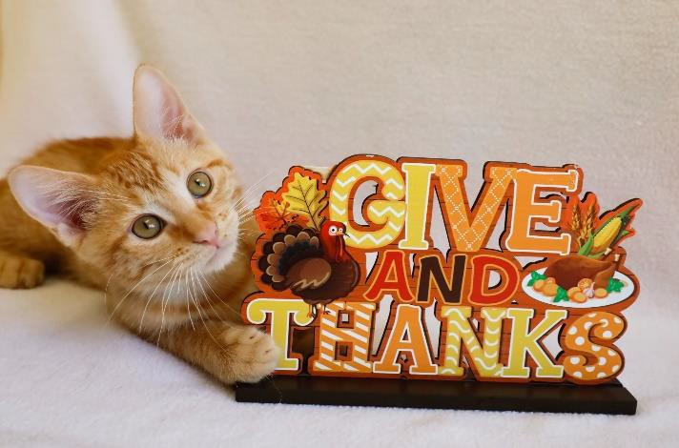

**Media Contacts:**

Christine Fixico-Silver, Fearless Kitty Rescue, info@fearlesskittyrescue.org, 480-837-7777

Mel Stevens, MWS Consulting, [mewstevensaz@](mailto:mewstevensaz@)gmail.com, 602-402-9097

***FOR IMMEDIATE RELEASE***

FEARLESS KITTY RESCUE ANNOUNCES GIVING TUESDAY CHALLENGE

***Donor Pledges to Match Up to $10K November 21-28***

**Fountain Hills, Arizona, November 16, 2023 *–*** A donor has pledged to match donations made to Fearless Kitty Rescue for Giving Tuesday up to $10,000 -- the Giving Tuesday challenge starts November 21 and continues through the Tuesday immediately after Thanksgiving – November 28. All donations received during that time frame will be matched up to that amount.

Christine Fixico-Silver, Director of Fearless Kitty Rescue, said, “We couldn’t have asked for a better gift for the kitties to be thankful for during this Holiday Season. Each time we look at Fearless Kitty Rescue’s kitties, we are reminded that these are the lucky ones.  There are millions of homeless cats in the United States and while we cannot make a significant difference in the overall number, each cat we save gets us closer to a better world—a world where cats can live their lives in loving homes, free from loneliness, cruelty, and neglect.”

Christine went on to say that FKR continues to surpass previous years in the number of cats we rescue and adopt.  So far in 2023, we have taken in over 300 cats and there is room to save more before the year is over.  We couldn’t save all these lives without the kindness and generosity of our donors. With Rescue expenses reaching an average of $20,000 each month to care for the kitties, every dollar counts!

For those who want to join the Fearless Kitty Rescue Tuesday Challenge there are several ways to donate between November 21st and the 28th:

* Mail: Fearless Kitty Rescue, 16832 Avenue of the Fountains, Fountain Hills, AZ 85268 –

if mailing make sure to get it postmarked to arrive by November 30th

* Mail Slot: drop an envelope in the mail slot on the wall at the Rescue
* In-person in the Boutique: Wednesday – Sunday 11am – 2pm
* On the website: [www.fearlesskittyrescue.org](http://www.fearlesskittyrescue.org/)

# About Fearless Kitty Rescue

Founded in 2012, Fearless Kitty Rescue is a recognized 501(c)(3) non-profit, no-kill cat rescue. Fearless Kitty Rescue is dedicated to providing a safe place for cats in need until they can be adopted into a loving home. At Fearless Kitty Rescue we believe in a future when all cats live happy and healthy lives, free from loneliness, cruelty and neglect.

Fearless Kitty Rescue also serves as an information resource to the community and all pet owners by providing education and information on responsible pet ownership, including the importance of spaying/neutering, positive behavior training, and good nutrition.

To learn more visit www.fearlesskittyrescue.org and follow: @fearlesskittyrescue on Facebook, Instagram & TikTok; @FearlessKitty12 on Twitter; and Fearless Kitty Rescue on YouTube.

###

