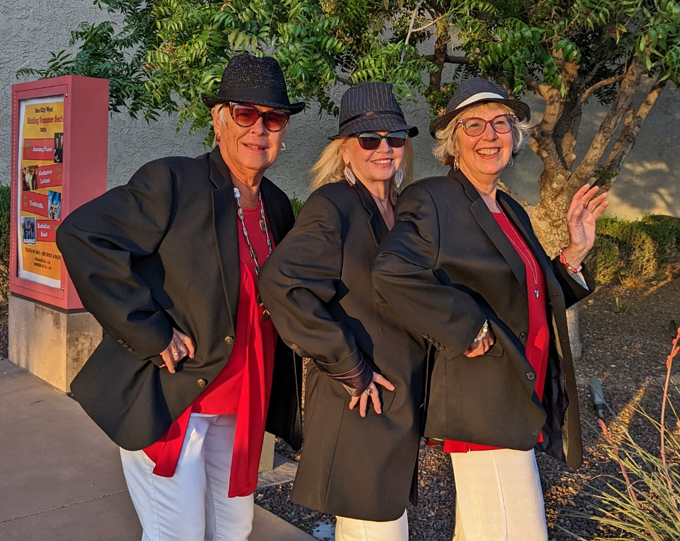
IND 5-3-2023 Press release – Karaoke Club of SCW
The Karaoke Club of SCW is a safe place to debut your singing skills, as Cindy Rickels, center discovered recently at the club’s regular Thursday evening meeting at the R.H. Johnson Social Hall in SCW. She had back-up support for the song,” Funky Town” from friends Tina McLaughlin, (L) and Karen Devers, (R).
The Karaoke Club of SCW is open to members and invited guests. They meet regularly on Thursday evenings at the R.H. Johnson Social Hall. Doors open at 5:00 p.m., singing begins at 6:00 p.m. There is a nominal singing fee, but listening is free. You do not need to sing to enjoy the camaraderie with this friendly group. The club plans to be open during the summer months in their, “Kool Karaoke Kabaret”.
Practice sessions are Monday evenings from 5:00 p.m. to 7:00 p.m. in the Arts and Crafts building at Beardsley Park Rec Center. Singers can access over 260,000 songs on the club’s data base or upload their own songs. Contact president Byron Brothers for more information: ByronBrothers@gmail.com. Check out the website:

