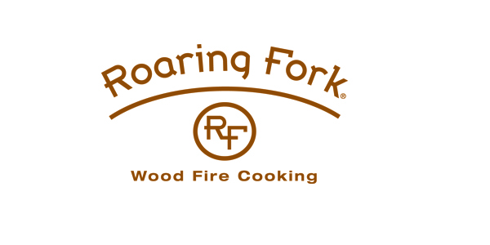
DINNER ON US
MEMORIAL DAY 2023 AT ROARING FORK

SCOTTSDALE, AZ (May 2, 2023) –In honor of Memorial Day on Monday, May 29th Roaring Fork will be commending those who have served our country, with a special Dinner on Us promotion. Diners can enjoy a BOGO (buy one, get one free) offer all evening long beginning at 4:00 p.m. Roaring Fork will be serving signature “wood fired” favorites including:

BIG ASS BURGER served with smoked peppered bacon, poblano pepper, cheddar, lettuce, tomato, onions, pickles, and fries
BRAISED PORK SHOULDER CARNITAS with Cowboy beans, street corn, and flour tortillas
BACON WRAPPED PORK TENDERLOIN served with poblano grits, charred corn, chipotle and balsamic reduction
ALL NATURAL BLACK ANGUS STEAKS hand cut in-house and served with caramelized shallot butter and chipotle demi glaze
SUGAR CURED DUCK BREAST with brussels sprouts, onion jam, cherry and demi glaze
BONELESS BUTTERMILK FRIED CHICKEN served with Mashed potato, and peppercorn gravy

ABOUT ROARING FORK
Roaring Fork's Wood Fired Cooking captures the spirit of bold American cuisine, creating flavors that crackle with a rugged edge. In the Old West, the best food was prepared on a simple wood fire. This same spirit, freshness and flavor are at the heart of every dish served at Roaring Fork. Select from lamb, chicken, beef, pork and fresh fish entrees all perfectly prepared by wood fire rotisserie, open flame grill or wood oven roasting. Roaring Fork is located at 4800 North Scottsdale Road in Scottsdale Arizona. For more information call 480-947-0795 or visit the website at www.roaringfork.com.

***
Media Contact:
BRIDGES MEDIA GROUP
Lindsey Gubler
Lindsey@bridgesmediagroup.com
602.614.3898

