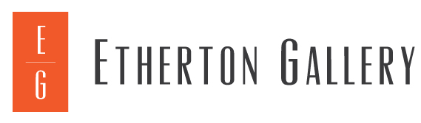

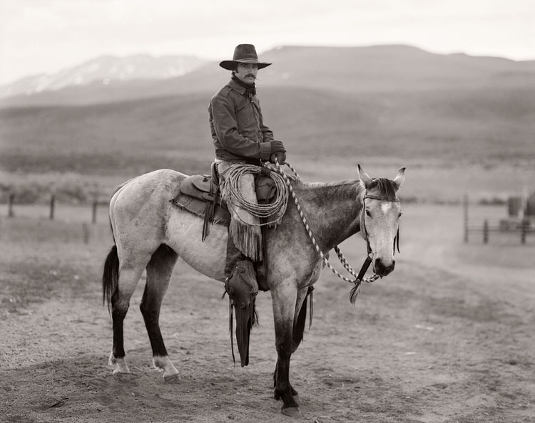
Martin Black, Stampede Ranch, Nevada, 1982, © Jay Dusard, courtesy Etherton Gallery

Etherton Gallery Opens New Summer Show
Jay Dusard: Cowboy with a Camera
(June 21-September 17, 2022)

Etherton Gallery is excited to welcome visitors to see the work of one of the most influential photographers of the American West, Jay Dusard, in our new summer show, Jay Dusard: Cowboy with a Camera. The exhibition opens June 21 and runs through September 17, 2022. A reception will be held at the gallery on Saturday, June 25, 2022, from 7:00 to 10:00 pm. Jay Dusard will attend. The opening will also feature live music with a special appearance by The Dusty Ramblers Project, based in Scottsdale, and Tucson’s own DJ Carl Hanni spinning tunes.

Cowboy with a Camera features a selection of monumental scale, cowboy portraits most of which were made during 1980-1982. In 1981, Jay Dusard was awarded a Guggenheim Fellowship and embarked on an epic adventure, photographing the working cowboys and women of North America. Over a period of two years, he traveled 25,000 miles with an 8 x 10 inch view camera, and rode and photographed at 45 ranches in the United States, Canada, and Mexico. The project was published as The North American Cowboy: A Portrait, in 1983.

Larger-than-life, and filled to the frame with the textures, details and locales of ranching life, images like Julie Hagen, Wagstaff Land & Cattle Co., Wyoming, 1981, and Bill Moorhouse, Bob Phillips, Jeff Shipp, Jack Bowlin and Jerry Brashears, ORO Ranch, Arizona, 1980, have an authenticity that comes from a working knowledge of life on a ranch.

A farm boy, Dusard had ridden and “followed” cows since childhood. Following his discharge from the Army in 1963, he did a brief stint on a ranch near the Arizona-Sonora border and fell in love with ranching and southern Arizona. He immersed himself in ranching life and photographed his subjects from the inside. As he said in a 2020 interview, “If I was part of it, the people I was photographing would trust me. They’d be more comfortable when the camera came out.”

Dusard’s portraits also reflect a sophisticated understanding of photography. He studied with the influential photographer Frederick Sommer, and considers him his mentor. Dusard positions his subjects directly in front of the camera, carefully choosing locations that emphasize their work as ranchers. His images have an almost tactile quality, and strike a balance between the physicality of the men and women in his photographs, and the abstract, graphic quality of the background details, which highlight the “landscape” in which they operate. The resulting images are both formally beautiful and powerful testaments to a way of life is disappearing. We are all the richer for his longstanding, passionate engagement with this world.

Join us at Etherton Gallery to celebrate an exhibition of Jay Dusard’s most iconic images in Jay Dusard: Cowboy with a Camera. For more information about Jay Dusard: Cowboy with a Camera, contact Daphne Srinivasan at Etherton Gallery (520) 624-7370 or info@ethertongallery.com

Jay Dusard (1937-)
Originally from Saint Louis, Missouri, Jay Dusard graduated from the University of Florida with a degree in architecture. A travel scholarship introduced him to the American West. Following his discharge from the Army in 1963, he worked for a ranch on the Arizona-Sonora border. He began photographing in 1965, and with the support of Frederick Sommer, taught photography at Prescott College in Arizona for seven years. In 1981 he was the recipient of a Guggenheim Fellowship, and the resulting body of work was published in The North American Cowboy: A Portrait (1983). This publication was followed by several other noted publications including a collaboration with writer Alan Weisman, La Frontera: The United States Border with Mexico (1986). In 1994 he published a second book of photographs, Open Country and collaborated with writer Dan Dagget on Beyond the Rangeland Conflict: Towards a West that Works, which was nominated for a Pulitzer prize. In 2005 he published Horses with writer Thomas McGuane. He was also the subject of a documentary directed by Michael Markee. Dusard’s photographs are in several private, corporate and public collections including: the Phoenix Art Museum, Glenbow Museum, Calgary; Colorado Springs Fine Arts Center; Consejo Mexicano de Fotografia, Mexico City; Art Museum of South Texas, Corpus Christi, Texas; the Center for Creative Photography at the University of Arizona, Tucson; Tucson Museum of Art; Los Angeles County Museum of Art; and Charles M. Russell Museum, Great Falls, Montana. His archive is at the Booth Western Art Museum in Cartersville, Georgia. Jay Dusard has lived on a ranch near Douglas, Arizona for almost five decades.

Etherton Gallery
Established in 1981, Etherton Gallery is best known for its expertise in post-World War II American and Mexican photography. In over 300 exhibitions and 150 art fairs, the gallery has highlighted the icons of photography and the contemporary artists changing its course. Etherton Gallery is dedicated to making great works of photography accessible to novices and experienced collectors alike. A champion of the arts of the Southwest and in particular Tucson, the gallery also exhibits top local and regional artists working in a variety of media. Etherton Gallery is a long-standing member of AIPAD (the Association of International Photography Art Dealers), and Terry Etherton serves on the Board of Directors. The gallery participates in fine art photography fairs including the AIPAD Photography Show NY, Classic Photographs LA, Photo LA, and Paris Photo. Etherton Gallery has placed work in several private, corporate, and public collections among them: The Museum of Modern Art, New York; Metropolitan Museum of Art, New York; Los Angeles County Museum of Art; San Francisco Museum of Modern Art; J. Paul Getty Museum, Los Angeles; Nelson-Atkins Museum of Art, Kansas City, Missouri; Museum of Fine Arts, Houston; and Library of Congress, Washington, D.C. Terry Etherton is an accredited member of the American Society of Appraisers and is available for appraisals, absentee bidding and collections consultation.

