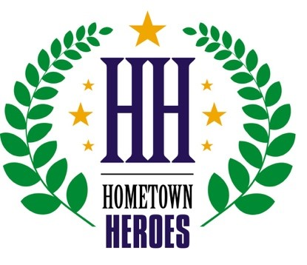

2019 Surprise Hometown Heroes Award Winners

Lifetime Achievement: Chuck Strange

Community Heroes:
- Arts Innovator: Connie Whitlock
- Educator: Heather Casey
- Emergency Responder: Officer Matthew Barker
- Mentor: Kent Guyer
- Spiritual: Chaplain Dan Brookey
- Veteran: Glenn Stark
- Volunteer: Sharon Beard

Business Heroes:
- Education: Ottawa University
- Entrepreneur: Julie Neal, TechCelerator
- Healthcare: Avein Saaty-Tafoya, Adelante Healthcare
- Nonprofit Organization: Surprise Youth Foundation
- Small Business: Tammy Fraser, Gifts to Go
- Large Business: Jenniffer Powell, Amtrust Bank
- Veteran Owned Business: Scott Boettcher, Veteran Tinting & Blinds

